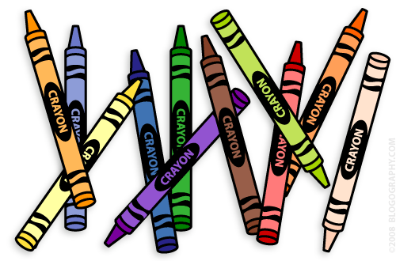
Our 1st Grade Classroom News
The Week of August 15th – 19th

Email: Lweeks@bluevalleyk12.org Website: www.bluevalleyk12.org/hes/lweeks
Upcoming Events

August 30th Early Release Day

- Students can bring their own snack to school every day.

- At least ONE challenge of the week is due every Friday. Students will be bringing home a homework notebook that they can complete them in today (Friday).

- Reminder that students need to bring their green VIP folders back each school day.
- To access the photo page on my website, the username and password are both weeks.

Math Challenge of the Week - We have been working on finding 2 numbers that equal another number. Give your child a number anywhere between 4 and 15 and see if they can come up with 2 numbers that make it. For example, if you pick the number 11, they may say 6 and 5 make 11 (6+5=11). To enrich your child more, give them a higher number that you think they can find what numbers make it.
Reading Challenge of the Week - Read a fiction book together and make connections with it (text-to-self connection)! How can the book relate to things that have happened in your life? You can have your child write about their text-to-self connection or you can write down what they say. If you want to enrich your child more, have them come up with a text-to-self and text-to-text (making a connection with another book) connection.
Writing Challenge of the Week - Make a list of topics with your child on what they can write about at home. Keep this list somewhere safe where they can always go back to look at if they need something to do! Have your child bring this list to class so I can see it! You can make the list as small or as big as you think is appropriate for your child! You can also try and get them to change some of their topics to more creative ones if they need more of a challenge.

Challenges of the Week
Tech of the Week

Website of the Week – www.funbrain.com is always a fun website for students. It has games for math and reading and most are right on 1st grade level. We will use this website at least a couple times this school year.
App of the Week - Make Dice - Create math dice for your student to practice their math facts! You can make any kind of dice using this app!
Important Info

